gunnersburyfriends.org

The impact of the Chiswick Curve on Gunnersbury Park

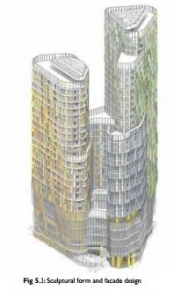
The Curve
A planning application for a 32 storey building at the Gunnersbury Roundabout is being considered by Hounslow Council. The site is the land presently surrounded by advertising hoardings between B&Q and the roundabout itself. This is “The Curve”.
It will have a major impact on the experience of visitors in many parts of the park, and anyone looking out of the new first floor museum galleries in the Large Mansion. A great deal of effort has been put into the protection and enhancement of the significant historic views of the landscape in the restoration work, and the building is so tall it will add greatly to the experience of confinement and restriction in a landscape which offers openness and freedom. People have enough of that in their daily lives – many go to parks to experience the very opposite, fresh air, the enjoyment of the natural world, the changes of light and weather.
The developers (Starbones) have submitted a mountain of documents, amongst which are visualisations of the impact of their building on the Park. These are such remarkable images that we thought we should publish them. Their assertions are that the building will have a moderate impact on park visitors, and if we do see it, the effect on us will be beneficial, because the architecture is so excellent.
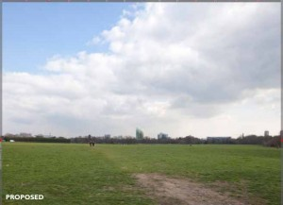
From north west entrance
The four viewpoints they chose to illustrate are from the north-west entrance (Lionel Road/ Pope’s Lane junction), from the path in front of the Temple,
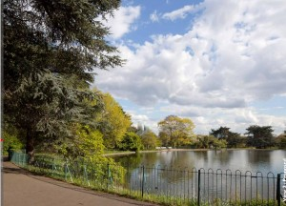
From path in front of Temple
from the terrace along the garden front of the Large Mansion,
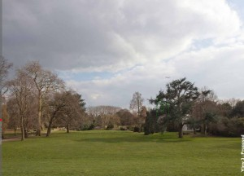
From the Terrace
and from the lawn near the Orangery.
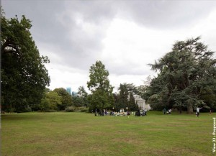
From the lawn near the Orangery
In almost every case the Park’s trees obscure the view of the building and moving the camera only a foot or two, or photographing in winter, would have made a very different picture. Just over the south wall of the Park is the cemetery, and the view from there – without any trees – is closer to the stark reality of what anyone moving through the Park is likely to experience.
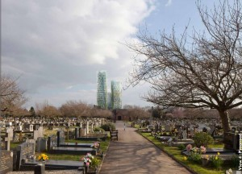
From the boundary of the Park and the Cemetery
The final photo is an attempt to show the cumulative effect of the other planning applications for the same area – Capital Interchange Way (22 storeys) and the blocks which will finance the Brentford Stadium in Lionel Road South. The next site for development is likely to be the B&Q site (next to the Curve site) and so within a short time visitors to Gunnersbury Park are likely to experience a veritable wall of high towers looming over their views, although the effect has been minimised by choosing this viewpoint.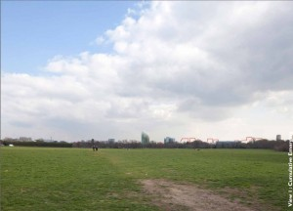
The predecessor of today’s mansions was built on the high terrace in the 17th century. Maynard’s main saloon opened onto a grand balcony explicitly to enjoy the view down to the Thames and up towards Richmond Hill. The last image is a “viewshed” developed for the Lottery bid to show how much you would have seen by standing on the terrace in the 18th century (the black dot), and you can still just get some of that today.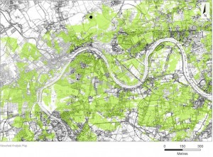
The spirit of the present restoration of the Park is to enhance the landscape and to help us appreciate the layers of history and change it has experienced. It will be wonderful when the work is done. A lot of money will be spent, and a lot of time and effort has been spent to make this happen. How much of that will be wasted if this and the other massive building schemes get approved?
The planning application documents are at: http://planning.hounslow.gov.uk/planning_search.aspx
Key in System Number: P/2015/5555 or Planning Reference: 00505/EY/P18
The document with the views is Environmental Statement Volume 3. We have put a copy here – beware, it is a very large file.
The deadline for comments is 1st February
The Planning Officer is Sarah Scannell, sarah.scannell@hounslow.gov.uk

